GAMBA

Gamba is a duo from Tel Aviv formed in 2021. The group consists of lead singer Anna M and JOS, a married couple recording music from their “home studio” (A hybrid guest room/play room). The duo was formed by past members of the Band “Anagrama”, which was disbanded in 2012.

Their first single, “Gutted”, was recorded mostly using Logic Pro, a midi controller and a “Yeti” microphone, to the dissatisfaction of Anna - who preferred working with professional musicians and studio engineers but was stuck with her incompetent no good husband instead.

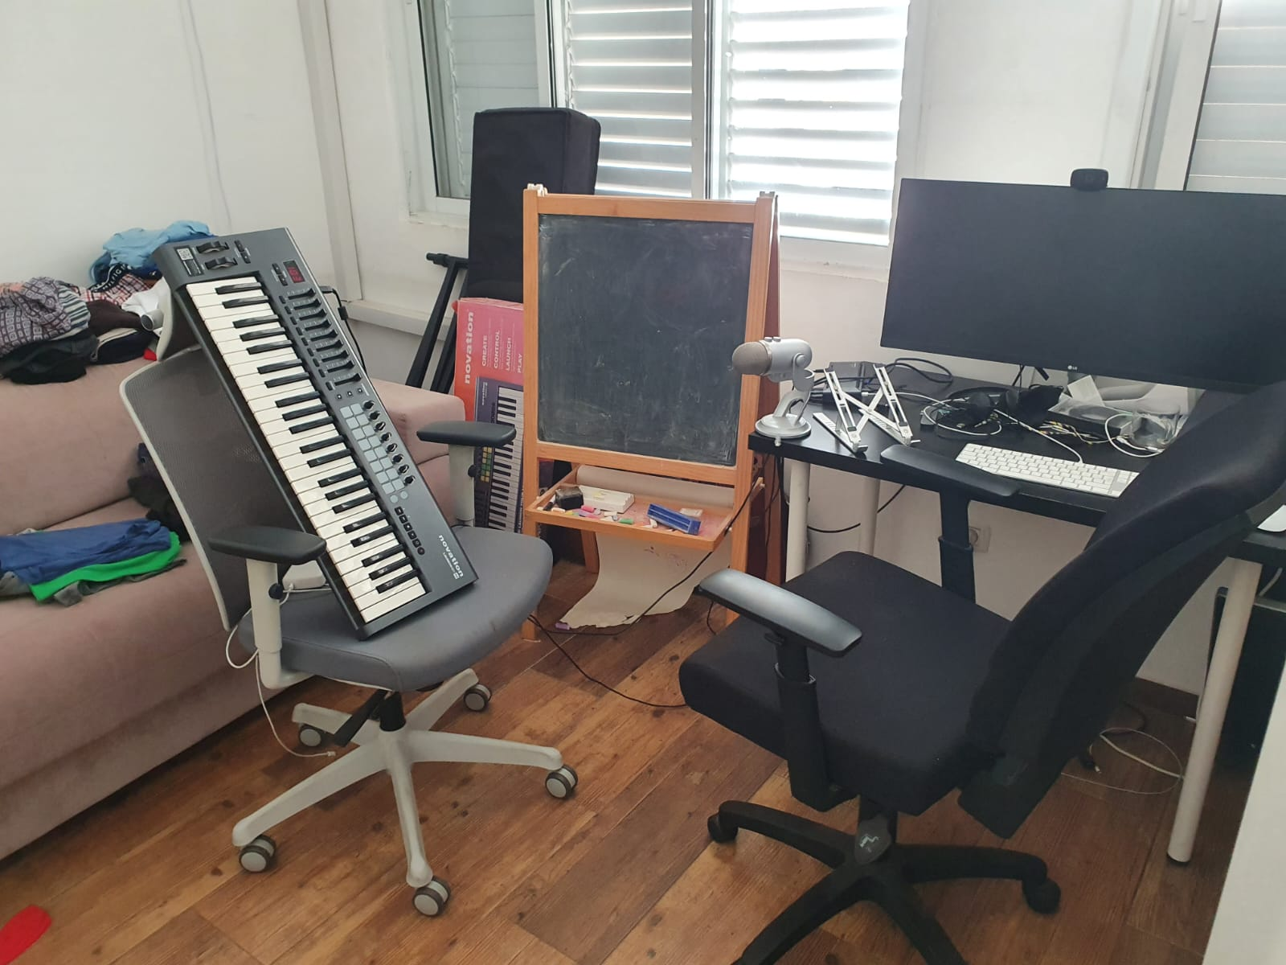
Contact:

Or Shachar,
052-6134557
orshachar23@gmail.com

