***UNDER STRICT EMBARGO UNTIL THURSDAY, SEPT 5 - 3PM PT***

LINKIN PARK ANNOUNCE NEW MUSIC AND TOUR:
TUNE-IN NOW FOR GLOBAL LIVESTREAM PERFORMANCE HERE

FIRST NEW MUSIC IN SEVEN YEARS “THE EMPTINESS MACHINE”: LISTEN HERE

STAY TUNED FOR PREMIERE OF JOE HAHN-DIRECTED VIDEO IMMEDIATELY FOLLOWING LIVESTREAM HERE

LOS ANGELES, NEW YORK, HAMBURG, LONDON, SEOUL & BOGOTA ARENA SHOWS ON SALE BEGINNING SATURDAY HERE

NEW ALBUM FROM ZERO ARRIVES NOVEMBER 15
PRE-ORDER HERE

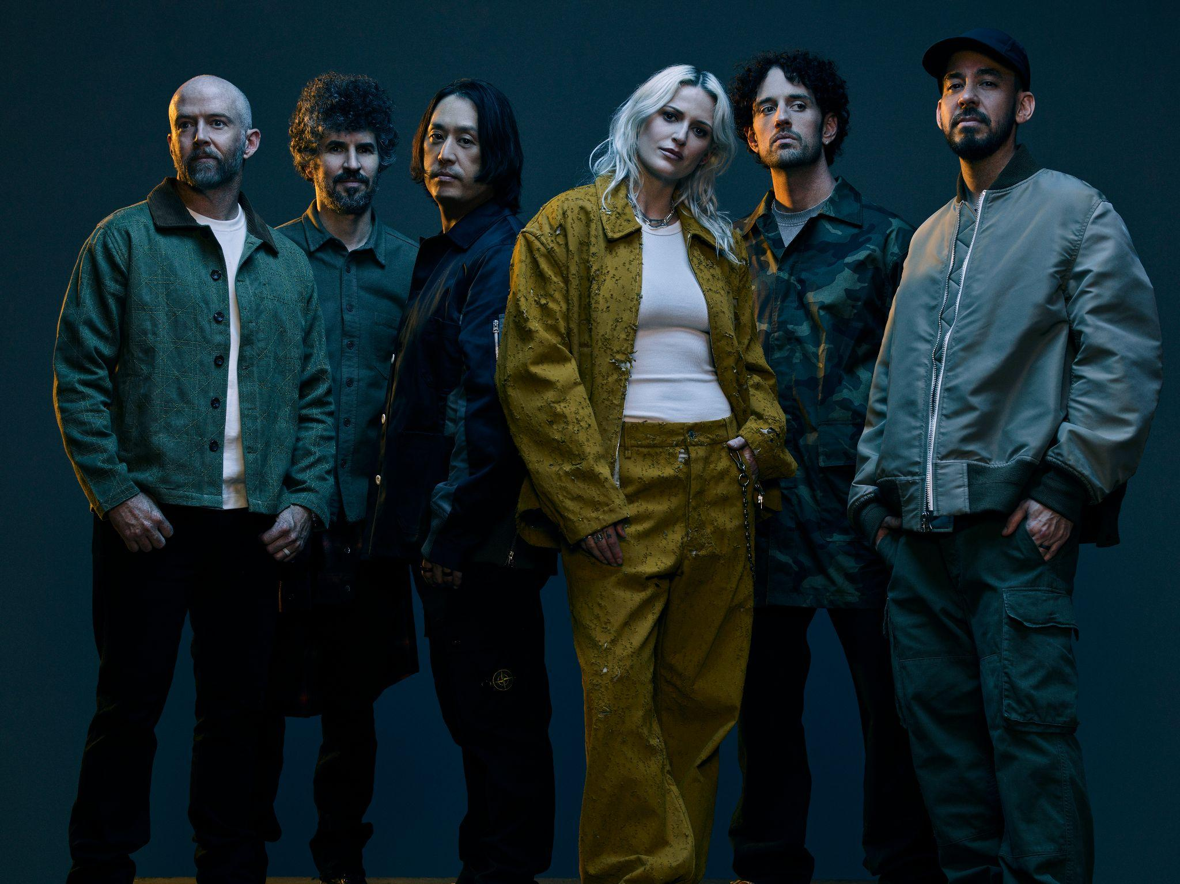
Credit James Minchin III. Download hi-res HERE

September 5, 2024 (Los Angeles, CA) – LINKIN PARK—Mike Shinoda, Brad Delson, Phoenix, Joe Hahn, alongside new members Emily Armstrong [of critically acclaimed band Dead Sara] as co-vocalist and Colin Brittain [songwriter/producer for G Flip, Illenium, One OK Rock] as drummer—share their first brand new music in seven years.

The iconic band shared a deluge of treats for fans: a new single (HERE) and video (premiering HERE at 4pm PT/7pm ET), for “The Emptiness Machine,” plus a global livestream performance (happening now HERE and available only for 24 hours), and the launch of 6 upcoming arena shows in Los Angeles, New York, Hamburg, London, Seoul, and Bogota as part of the From Zero World Tour. LP Underground fan club exclusive pre-sales start September 6 and general on-sales September 7. Go to LinkinPark.com for more info.

These surprises herald the arrival of LINKIN PARK’s first album since 2017, FROM ZERO, on November 15. Pre-order/Pre-save HERE via Warner Records.

Tomorrow, Friday September 6th, the band joins long-time friend and Apple Music host Zane Lowe for an in-depth candid conversation about the incredible legacy of Linkin Park, the 7-year long journey to new music and their excitement for the future. Fans can tune in at 6AM PT to watch the full interview HERE.

Without expectations, Shinoda, Delson, Farrell, and Hahn quietly began meeting up again in recent years. Rather than “trying to restart the band,” their instinct was to simply spend more time together, and reconnect with the creativity and camaraderie that has been at the core of their friendship since college. During this time, they invited various friends and cohorts to join them in the studio; among the guests, they found a special kinship with Armstong and Brittain. A natural chemistry drew these musicians back into its gravitational pull as they logged more and more hours in the studio. It was the sound of lifelong musicians rediscovering the uncontainable energy of a new beginning once again. Over this season, FROM ZERO was born.

About the new era, Shinoda stated, “Before LINKIN PARK, our first band name was Xero. This album title refers to both this humble beginning and the journey we’re currently undertaking. Sonically and emotionally, it is about past, present, and future—embracing our signature sound, but new and full of life. It was made with a deep appreciation for our new and longtime bandmates, our friends, our family, and our fans. We are proud of what LINKIN PARK has become over the years, and excited about the journey ahead.”

Right out of the gate, “The Emptiness Machine” channels the DNA of LINKIN PARK, harnessing the band’s explosive energy and retaining the hallmarks of their instantly identifiable and inimitable sound. A chameleonic and catchy anthem, Shinoda’s hypnotic melodies hand off to Armstrong’s blistering chorus, over distorted riffs and head-nodding drums.

Shinoda elaborated, “The more we worked with Emily and Colin, the more we enjoyed their world-class talents, their company, and the things we created. We feel really empowered with this new lineup and the vibrant and energized new music we’ve made together. We’re weaving together the sonic touchpoints we’ve been known for and still exploring new ones.”

Ultimately, with FROM ZERO, the band is looking to harness the purest energy of their past, present, and future. The new era has officially begun.

FROM ZERO WORLD TOUR 2024

September 11, 2024 | Kia Forum - Los Angeles, CA

September 16, 2024 | Barclays Center - New York, NY

September 22, 2024 | Barclays Arena - Hamburg, Germany

September 24, 2024 | The O2 - London, UK

September 28, 2024 | INSPIRE Arena - Seoul, South Korea

November 11, 2024 | Coliseo Medplus - Bogota, Colombia

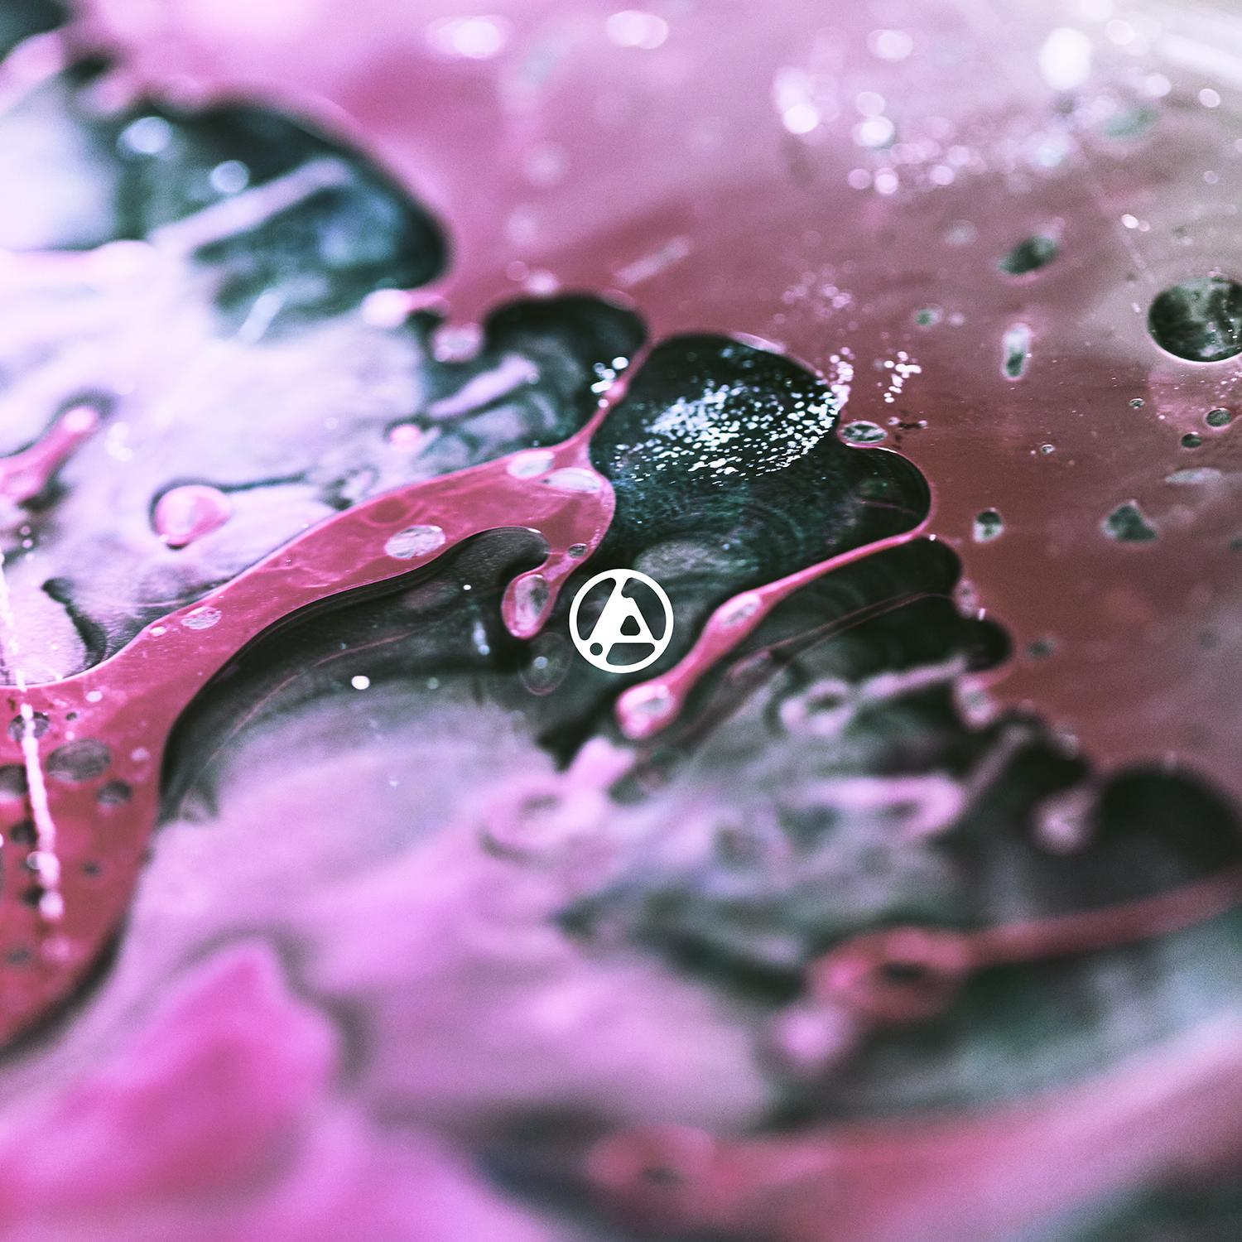
Download hi-res album art HERE

FROM ZERO TRACKLIST

- From Zero (Intro)
- The Emptiness Machine
- Cut The Bridge
- Heavy Is The Crown
- Over Each Other
- Casualty
- Overflow
- Two Faced
- Stained
- IGYEIH
- Good Things Go

ABOUT LINKIN PARK:
LINKIN PARK emerged as an innovative musical force and are one of the best-selling artists of the last twenty years. Their RIAA Diamond-certified full-length debut, Hybrid Theory, stands out as the “best selling debut of the 21st century,” while landmark sophomore album Meteora bowed at #1 on the Billboard Top 200 before going 8X-Platinum in the U.S. The band’s worldwide sales across the entire catalog eclipses 100 million, and among numerous accolades and honors, they have garnered 2 GRAMMY® Awards, 5 American Music Awards, 4 MTV VMA Awards, 10 MTV Europe Music Awards and 3 World Music Awards. Selling out stadiums worldwide, they’ve headlined the largest festivals globally and also remain the first and only Western rock band to play a five-stadium tour in China. 2017’s One More Light marked their fifth #1 debut on the Billboard 200. In 2020, the band celebrated their groundbreaking debut album, Hybrid Theory, by releasing a comprehensive 20th anniversary edition super deluxe box set which features their RIAA Diamond-certified single “In The End.” In 2023, the band released Meteora 20th Anniversary Edition, which topped the charts and featured the newly-uncovered song “Lost.” The emotionally charged single was originally recorded during sessions for their second studio album Meteora (2003), and soon after its 2023 release, “Lost” hit #1 at both Alternative and Rock radio. 2024 marked the release of their first greatest hits package Papercuts, featuring vault track “Friendly Fire” that similarly topped both the Alternative and Rock charts. LINKIN PARK have always prioritized charity and goodwill in an effort to make the world a better place, helping to raise millions over the years for victims of natural disasters. Today, LINKIN PARK’s imprint on music and culture continues to expand and magnify.

Follow LINKIN PARK:
Official Site | Facebook | X | Instagram | YouTube | TikTok | Discord

Download hi-res assets:
press.warnerrecords.com/linkinpark

